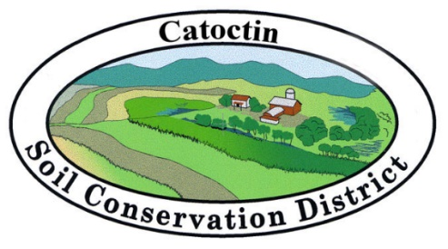

92 Thomas Johnson Drive, Suite 230, Frederick, MD 21702
Phone: 301-695-2803 Ext. 3 Fax: 301-694-0270
Email: soil.conservation@comcast.net

Agenda
Catoctin Soil Conservation District Regular Meeting
Tuesday, March 21, 2023 - 9:00 AM
Burkittsville Ruritan, 500 East Main Street, Burkittsville

- Call to Order Sowers
- Approval of Minutes from Last Meeting Sowers
- Approval of Minutes from December Joint Meeting Sowers
- Financial Reports
  - Treasurer’s Report Holter
  - Bank Account Reconciliation Report Hutchinson
  - Expenses for the Month
    - Operating Account Hutchinson
    - Joint Urban Checking Hutchinson
- Old Business Sowers
  - Board Merger
  - SSCC meeting
  - Other Old Business
- Current Business Sowers
  - Josh Smith- RC&D
  - D&O Insurance
  - General Funds Budget
  - District Digest
  - NM Planning at the SCD
  - Signature Authorization Policy
  - Farm Safety Camp
  - Other Current Business
- Committee Reports
  - RC&D Orlowski
  - Info/Education - Envirothon Falkenstein
  - Awards Arnold
  - Legislative Holter
  - Ag Complex Sowers
- Communications Hutchinson/Cammauf
- NRCS Update Cammauf
- Urban Report Hutchinson
- Other Business from the Floor Sowers
- Cooperating Agencies (MDA, Extension)
- Next Monthly Board Meeting (April 18, 2023) Sowers
- Adjournment
- Closed Session

