February 7, 2023
Registration: 8am
Event: 8:30am – 2:40pm
LUNCH PROVIDED!
Digging Deeper into Soil Health

At the Great Frederick Fairgrounds, Null Building (Building No. 9)
797 E Patrick St, Frederick, MD 21701

Frederick and neighboring county producers are invited to attend Digging Deeper into Soil Health presented by Jim Hoorman of Hoorman Health Services and hosted by the Catoctin and Frederick Soil Conservation Districts and Frederick County Farm Bureau!
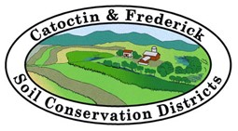
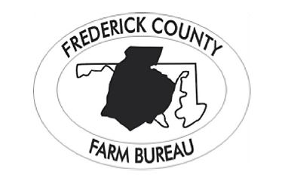
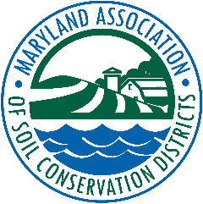
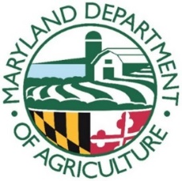

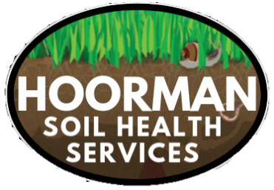
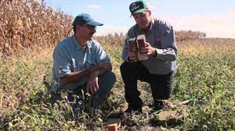
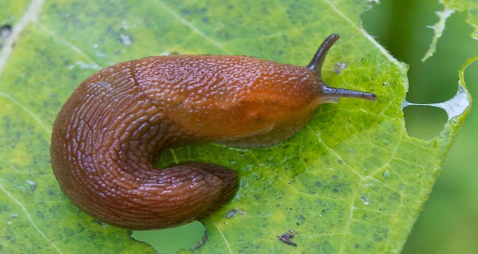
Certified Crop Advisor and MD Nutrient Management continuing education credits are AVAILABLE!

RVSP TODAY!
By Eventbrite: Register Here!
By Phone: 301-695-2803 ext. 3
Please RSVP by January 31st to be counted for lunch!
Topics Include:
- SLUGS
- The nitty gritty of soil structure and composition
- WHY you may not be seeing improvements despite your best efforts
- Micronutrients and humates for plant health
- Importance of soil ecology and nutrient cycling
- State and federal conservation program updates and new opportunities!

This Photo by Unknown Author is licensed under CC BY-SA-NC

